Lecture XII
Antiepeleptic drugs
The diagnosis of a first epileptic seizure or epilepsy, at primary care facilities, is often subjective and prone to error because it is usually based on eyewitness accounts of the episodes.6,12 An incorrect diagnosis, especially of the seizure type, however, can have far-reaching negative consequences for the patient, including loss of work and driving privileges, potential toxic or ineffective medication given, and other socioeconomic consequences.13 Classification of Epileptic Seizures and Recommended Initial Drug Therapy The 1981 classification of the epileptic seizure types14 and the 1989 classification of epileptic syndromes and epilepsies15 are still widely accepted and workable because their accuracy facilitates diagnosis, drug selection, and precise discussion of seizure disorders.6,16 Seizures are classified, based on their initial signs and symptoms and the pattern seen on the electroencephalogram (EEG), into two broad categories as generalized seizures or as partial seizures.13 Each of the epilepsy types is characterized by an abnormal pattern in the EEG. The EEG indicates sudden, excessive electrical activity in the brain. Most of the currently available AEDs work by preventing, stopping, or lessening this electrical activity. The precise causes of these abnormal changes is still unknown; however, it has been hypothesized that there is a site or focus of damaged or abnormal hyperexcitable neurons in the brain. These neurons can fire excessively and sometimes recruit adjacent neurons that in turn induce other neurons to fire. Thus, the location and the extent of the abnormal firing is essential for the determination of the epilepsy types.16 PRIMARY GENERALIZED SEIZURES Two major types of generalized seizures are the primarily generalized tonic–clonic seizures (grand mal) and the absence (petit mal) seizures. The typical primarily generalized tonic–clonic seizure is often preceded by a series of bilateral muscular jerks followed by loss of consciousness, which in turn is followed by a series of tonic and then clonic spasms. The typical absence seizure (classic petit mal) consists of a sudden brief loss of consciousness (10 seconds), sometimes with no motor activity, although often some minor clonic motor activity exists. Based on a recent evidencebased metaanalysis of AED efficacy and effectiveness, the recommended initial monotherapy for patients with generalized seizures are CBZ, oxcarbazepine (OXC), lamotrigine, VPA, phenytoin, and topiramate (TPM), whereas children with absence seizures are best treated with lamotrigine, VPA, or ethosuximide.6,13 PARTIAL SEIZURES Major types of partial seizure are simple partial seizures (focal) and complex partial seizures (temporal lobe or psychomotor). Partial seizures are the most common seizure types experienced by approximately 60% to 70% of the adult patients. A prototypic simple partial seizure is Jacksonian motor epilepsy in which the Jacksonian march may be seen. As the abnormal discharge proceeds over the cortical site involved, the visible seizure progresses over the area of the body controlled by the cortical site. Partial seizures, if not controlled, may progress to another seizure type known as the secondarily generalized partial seizures (tonic–clonic or grand mal). The first-line treatment for patients with newly diagnosed or untreated simple partial seizures are CBZ or phenytoin for adults, lamotrigine or gabapentin for elderly adults, and OXC for children.6,13 The complex partial seizure is represented by the psychomotor or temporal lobe seizure. There is an aura, then a confused or bizarre but seemingly purposeful behavior lasting 2 to 3 minutes, often with no memory of the event. The seizure may be misdiagnosed as a psychotic episode. Although the initial treatment is the same, it is much harder to control complex partial seizures. Anticonvulsants Used in Neuropathic Pain Neuropathic pain, despite its heterogeneity in etiology and anatomical locations, is characterized by a neuronal hyperexcitability in damaged areas of the nerves. This neuronal hyperexcitability and many of the corresponding cellular changes is quite similar to that of epilepsy. Thus, it is not surprising that anticonvulsants such as CBZ, gabapentin, and more recently its close analog, pregabalin were approved for relieving pains associated with diabetic neuropathy, trigeminal neuralgia, and other neuropathic pains.17 Both gabapentin and pregabalin have become an important treatment option in neuropathic pain because of their lack of potential drug interactions and minimal side effect profiles. MECHANISMS OF ACTION OF ANTICONVULSANTS At the cellular level, three basic mechanisms are believed to contribute to the antiepileptic action of the currently marketed anticonvulsants.18,19 These are (a) modulation of voltage-gated ion channels (Na, Ca2, and K), (b) enhancement of -aminobutyric acid (GABA)-mediated inhibitory neurotransmission, and (c) attenuation of excitatory (particularly glutamate-mediated) neurotransmission in the brain. Many of AEDs, especially the newer drugs, work by more than one of the above mechanisms of actions, therefore possessing a broader spectrum of antiepileptic action. Voltage-Gated Ion Channels as Targets for Anticonvulsants VOLTAGE-GATED SODIUM CHANNELS Voltage-gated sodium channels (VGSCs) in the presynaptic nerve terminal of the excitatory glutamate receptors are the molecular target for phenytoin, CBZ, and lamotrigine as well as some of the newer AEDs, such as OXC, felbamate (FBM), and zonisamide.18 These aromatic AEDs inhibit excessive neuronal firing by binding to a site near the inactivation gate, thereby prolonging inactivation of VGSCs.20 Figure 14.1 illustrates how phenytoin interacts with the hypothetical inactivation gate receptor according to a pharmacophore model suggested by Unverferth et al.21 as a result of molecular simulations with these aromatic AEDs. This model includes an aromatic binding site and two separate hydrogen bonding sites for interacting with potent AEDs such as phenytoin and lamotrigine. VOLTAGE-GATED CALCIUM CHANNELS The voltage-gated calcium channels (VGCCs) are essential in regulating Ca2 signaling, which is associated with many important cellular events such as the release of excitatory glutamate neurotransmitters, the plasticity changes

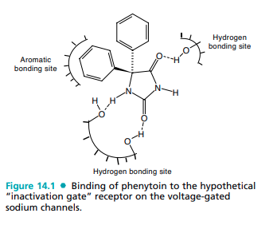
of long-term potentiation in learning and memory, and the maintenance of homeostasis of nerve cells. It has been suggested that excessive influx of Ca2 plays a critical role in the induction and progression of epileptic seizures.22,23 There are distinct classes of VGCCs. The high-threshold L-type Ca2 channels in the presynaptic glutaminergic receptors require strong depolarization for activation and are the primary molecular targets of gabapentin and pregabalin, both of which are effective in refractory partial seizures.22,24 On the other hand, the low-threshold T-type Ca2 channels require only weak depolarization for activation and are the molecular targets of AEDs such as ethosuximide and zonisamide.18,25 VOLTAGE-GATED POTASSIUM CHANNELS Potentiation of the voltage-gated K channels is another attractive target for designing of newer AEDs, because they are intimately associated with the membrane repolarization processes.20 Levetiracetam (LEV), a novel AED recently marketed for the adjunctive therapy of refractory partial seizures in adults, has been suggested to work by reducing the voltage-operated A-type potassium currents as one of its mechanism of actions.26,27 GABAA Receptors as Targets for Anticonvulsants It is now well recognized that cellular excitability leading to convulsive seizures can be attenuated by GABAergic stimulation in the brain.19 The GABAA receptor is one of two ligand-gated ion channels responsible for mediating the effects of GABA, the major inhibitory neurotransmitter in the brain.18,19 Activation of the GABAA/benzodiazepine (BZD) receptors/chloride channel complex allows increased chloride conductance, thereby preventing the spread of neuronal excitations.28,29 The potential targets for AED’s action on the GABAergic inhibitory synapses include (a) drugs that enhance the biosynthesis of GABA (gabapentin, pregabalin, and VPA), (b) drugs that inhibit GABA degradation (vigabatrin), (c) drugs that inhibit the reuptake of GABA (tiagabine), and (d) drugs that bind to an allosteric site on the postsynaptic GABAA receptor complex that increase chloride conductance (barbiturates, BZDs, neurosteroids, FBM, TPM).19 DRUGS THAT ENHANCE THE BIOSYNTHESIS OF GABA GABA, the major inhibitory neurotransmitter in the brain, is biosynthesized at the GABAergic neurons by the decarboxylation of the amino acid, L-glutamic acid (itself an excitatory amino acid neurotransmitter in the brain). The rate-limiting enzyme that catalyzes this conversion is Lglutamic acid decarboxylase (GAD). The essential cofactor for this enzymatic reaction is pyridoxal phosphate (vitamin B6) (see Fig. 14.2). GABA, after its release from the synaptic nerve terminal, is degraded by another pyridoxaldependent enzyme, the GABA transaminase (GABA-T), which transfers an amino group from GABA to -ketoglutarate producing L-glutamic acid and succinic acid semialdehyde (SSA). As shown in Figure 14.2, SSA is further oxidized by the action of the enzyme succinic semialdehyde dehydrogenase (SSADH, an aldehyde dehydrogenase) to succinic acid that can enter the TCA cycle for the production of additional -ketoglutarate or be further reduced by SSA reductase (an alcohol dehydrogenase that catalyzes the interconversion of SSA and 4-hydroxybutyric acid).30 Being a 3-substituted GABA, gabapentin and especially pregabalin, may have the ability to activate GAD,31 in addition to their major anticonvulsant action at the high-threshold L-type Ca2 channels in the presynaptic glutaminergic receptors.24 Both of these drugs are weak activators of GAD; however, their pharmacological actions on the GAD can not be discounted because gabapentin was able to elevate brain GABA levels (75%–100%) in patients with epilepsy within hour after the first dosing.32 Similar to gabapentin and pregabalin, VPA, also elevates brain levels of GABA in patients with epilepsy.30 It is generally agreed that VPA inhibits SSADH, the enzyme responsible for conversion of SSA to succinic acid. The exact mechanism of action of how this inhibition enhances GABA levels in the brain is still the subject of much debate (i.e., from an indirect stimulation of GAD to an inhibition of GABA-T). However, if we take into account that GABA also inhibits SSA reductase, an enzyme that reduces SSA to -hydroxybutyric acid, an epitogenic metabolite of GABA. Thus, it is reasonable to propose that VPA elevates GABA levels by reversing the transamination reaction mediated by GABA-T because of the accumulation of its product, SSA at the enzyme active site of GABA-T (Fig 14.2).
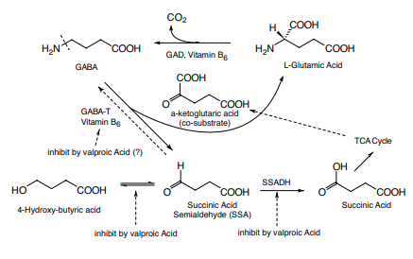
DRUGS THAT INHIBIT GABA DEGRADATION Vigabatrin (-vinyl-GABA) is an irreversible inhibitor of GABA-T, rationally designed based on the biochemical mechanism of transamination reaction.19,33 Briefly, vigabatrin, because of its structural similarity, competes with GABA for binding to GABA-T and forms a Schiff base intermediate with the cofactor, pyridoxal phosphate similar to GABA. However, unlike its substrate GABA, during the process of transferring the amino group to the pyridoxal phosphate, a reactive intermediate is formed with vigabatrin that immediately attaches itself to the active site of the enzyme, thereby irreversibly inhibiting GABA-T and increasing GABA levels in the brain. DRUGS THAT INHIBIT REUPTAKE OF GABA Released GABA is actively taken back into the GABAergic neurons or glial cells in the brain by GABA transporters (GATs).28,34 Tiagabine, structurally related to nipecotic acid, is a selective inhibitor of the neuronal and glial GAT1 at the GABAergic neurons and an effective drug for the treatment of patients with refractory epilepsy.34 Addition of two lipophilic heterocyclic rings to the nicopetic acid moiety did not interfere with its ability to bind GAT1 but actually allows tiagabine to cross into the brain freely and also more selectively than nicopetic acid toward GAT1.34 DRUGS THAT BIND TO THE GABAA RECEPTOR COMPLEX AND MODULATE CHLORIDE INFLUX Many clinically useful anxiolytic hypnotic–sedatives and some AED drugs such as BZDs, and barbiturates (e.g., phenobarbital) exert their pharmacological actions by interacting with a discrete neuronal site on the GABAA- BZD receptorchloride channel complex.35 The GABAA-chloride ionophore is a glycoprotein pentamer that contains two , two , and one subunit and is present throughout the mammalian brain.28,35 It has been hypothesized that binding of BZD agonists such as clonazepam to its receptor enhances GABAmediated inhibitory neurotransmission by increasing the frequency of chloride channel openings. TPM, a broad-spectrum AED, also binds and increases the frequency of chloride channel opening but at a different site than the BZDs.18 Barbiturates, on the other hand, bind to a third binding site on the GABAA receptor complex and increases the duration of chloride channel openings.35 It has been hypothesized that the binding of these drugs to their respective binding sites induces conformational changes, thereby allowing GABA to work more efficiently to modulate chloride channel openings. Excitatory Glutamate-Mediated Receptors as Target for Anticonvulsants The acidic amino acids, L-glutamate and L-aspartate, are the most important excitatory neurotransmitters in the brain acting through two distinct families of glutamate receptors, the ligand-gated, ionotropic receptors and the G-protein–coupled metabotropic receptors.36 The ligand-gated glutamate receptors such as N-methyl-D-aspartic acid (NMDA)/-amino-3- hydroxyl-5-methyl-4-isoxazole propionic acid (AMPA) receptors modulate sodium and calcium influx and are involved in mediating excitatory synaptic transmission including the initiation and spread of seizure activity. Activation of these receptors is responsible for important functions in the brain including long-term potentiation in memory acquisition, learning, and some neurodegenerative disorders.22,37 These receptors are potential therapeutic targets for epilepsy and other neurodegenerative disorders such as stroke and head injury, Alzheimer, and other chronic debilitating disorders. However, efforts in finding effective and safe NMDA antagonists have failed because of their toxicities and intolerable side effects.38 Thus, with the exception of TPM, which deriving some of its antiepileptic action by modulating the AMPA receptor and FBM, which appears to bind to the glycine binding site on the NMDA receptor, none of the current AEDs has any direct action at the postsynaptic glutamate receptors.19 Metabotropic glutamate receptors, on the other hand, modulate the release of glutamic acid, GABA, and other important neurotransmitters in the brain. Thus, these receptors are exciting new therapeutic targets for designing medications for pain, addiction, Parkinson disease, schizophrenia, and other neurodegenerative disorders.28 CLINICALLY IMPORTANT ANTICONVULSANTS There is very little SAR among the clinically useful anticonvulsants except within each structure type, primarily effecting their side effects and toxicities. Thus, these aspects of medicinal chemistry will be covered under each structure type or under the individual drug monographs covered in this section. Valproic Acid (Depakote, Depakene, Depacon) VPA is an established AED with a simple chemical structure but an unusually broad spectrum of action. It is generally well tolerated, but its use is limited by two rare but significant toxic side effects (hepatotoxicity and teratogenicity) that can be dose-dependent or idiosyncratic in nature.9,39,40 These drawbacks are apparently shared by its equipotent active metabolite, (E)-2-propyl-2-pentenoic acid (2-ene-VPA) (Fig. 14.3). VPA is also an important inhibitor of the cytochrome P450 isozymes, mainly of CYP2C9 and also of uridine diphosphate (UDP)-glucuronyl transferase and epoxide hydrolase.10 This inhibition is competitive and dose-dependent, and its effect is observed when sufficient concentrations of VPA is achieved (usually within 24 hours). Thus, an increase in the plasma concentrations of other AEDs such as lamotrigine is to be expected after dosing with VPA. Metabolism of VPA is very complex and is the result of hepatic mitochondrial 5 `-oxidation and microsomal oxidations, catalyzed by CYP2C9, CYP2C19, and CYP2E1 and possibly CYP3A4, and glucuronidations.39,40 At least 10 metabolites have been identified. The major urinary inactive metabolite is 2-propyl-3-keto-pentanoic acid (3-keto-VPA) and an equipotent active metabolite, (E)-2-ene-VPA. Other minor metabolites identified are their hydroxylated or dehydrated products, and 2-propylglutaric acid (see Fig.14.3 for their structures). All of these metabolites are excreted as O-glucuronides. The hepatotoxicity of VPA is most likely associated with 2, 4-diene-VPA and/or 4-epoxy-VPA rather than the 4-ene-VPA originally suggested because its closely related analogs, -fluoro-4-ene-VPA and -fluoro-VPA, were not found to have any liver toxicity.41 These toxic or reactive metabolites are normally detoxified as a cysteine conjugate via the GSH/glutathione transferase metabolic pathway.41 Alternatively, the 4-epoxy-VPA can also be deactivated by epoxy hydrolase to form the corresponding inactive VPA-4, 5-diol (Fig. 14.3). It should be pointed out that these toxic metabolites may also react with the sulfhydryl group or other nucleophiles on the cellular proteins, thereby forming covalently bonded haptens. These drug-modified proteins then elicit and become the target of an immune response, thereby producing the observed idiosyncratic allergic reactions in clinically susceptible patients.
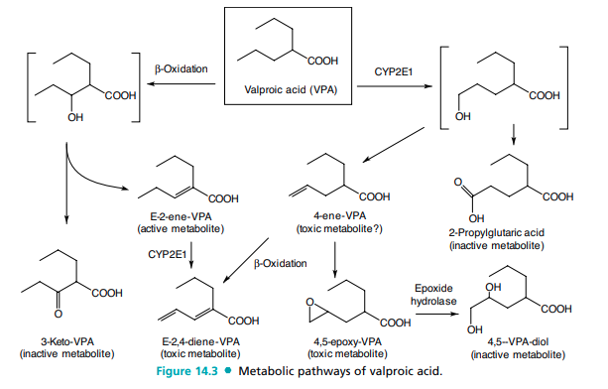
Valrocemide (valproyl glycinamide, VLR) and DPVPA (SPD-421) are two novel VPA analogs currently in phase II clinical trials42,43 (Fig. 14.4). The anticonvulsant properties of VLR were found to be a result of the parent molecule and not because of its metabolic biotransformation to VPA or glycine (i.e., itself an inhibitory neurotransmitter in the brain). The major in vivo inactive metabolite is valproyl glycine, which is formed via the normal metabolic inactivation of peptide drugs.42 SPD-421, on the other hand, is a phosphatidylcholine derivative of VPA. The phospholipid part of the molecule significantly increases its lipid solubility and facilitates its transport into the brain. Furthermore, SPD-421 was found to be minimally metabolized in the liver with most of the drug renally eliminated. However, upon entry into the brain, SPD-421 is specifically cleaved by the enzyme, phosplipase A2 (PLA2), at the site of seizure to release VPA (there is evidence that the activity of PLA2 is significantly increased in neurons associated with epileptiform activity prior to seizure attack).43 Thus, unlike VPA, both of these drugs are said to have low drug-interaction potentials. Phenytoin (Dilantin, Kapseals, Phenytek) and Fosphenytoin (Cerebyx) Phenytoin, 5,5-diphenylhydantoin (Dilantin), is a prime example of an effective anticonvulsant acting through its action at the VGSC.18 Phenytoin is structurally very similar to phenobarbital but lacks the dependence liability (see the discussion of barbiturate-type anxiolytic hypnotic–sedative drugs under “CNS Depressants” in this
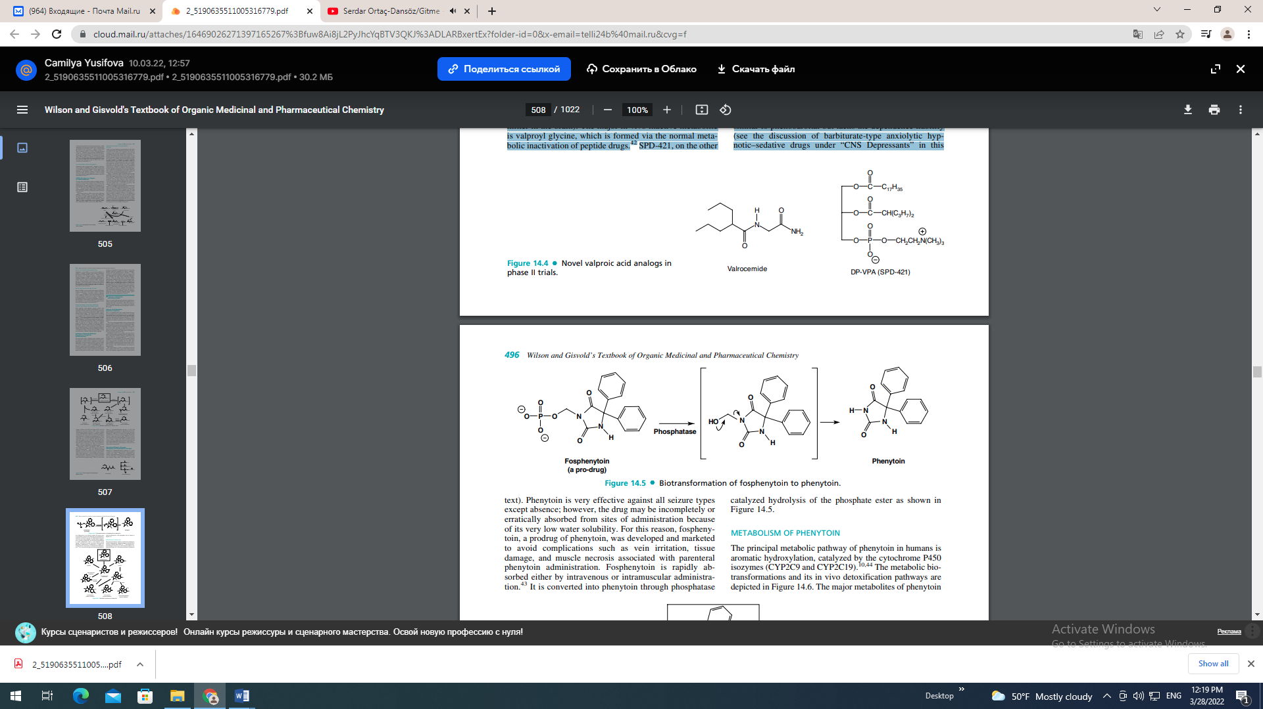

Phenytoin is very effective against all seizure types except absence; however, the drug may be incompletely or erratically absorbed from sites of administration because of its very low water solubility. For this reason, fosphenytoin, a prodrug of phenytoin, was developed and marketed to avoid complications such as vein irritation, tissue damage, and muscle necrosis associated with parenteral phenytoin administration. Fosphenytoin is rapidly absorbed either by intravenous or intramuscular administration.43 It is converted into phenytoin through phosphatase catalyzed hydrolysis of the phosphate ester as shown in Figure 14.5. METABOLISM OF PHENYTOIN The principal metabolic pathway of phenytoin in humans is aromatic hydroxylation, catalyzed by the cytochrome P450 isozymes (CYP2C9 and CYP2C19).10,44 The metabolic biotransformations and its in vivo detoxification pathways are depicted in Figure 14.6. The major metabolites of phenytoin
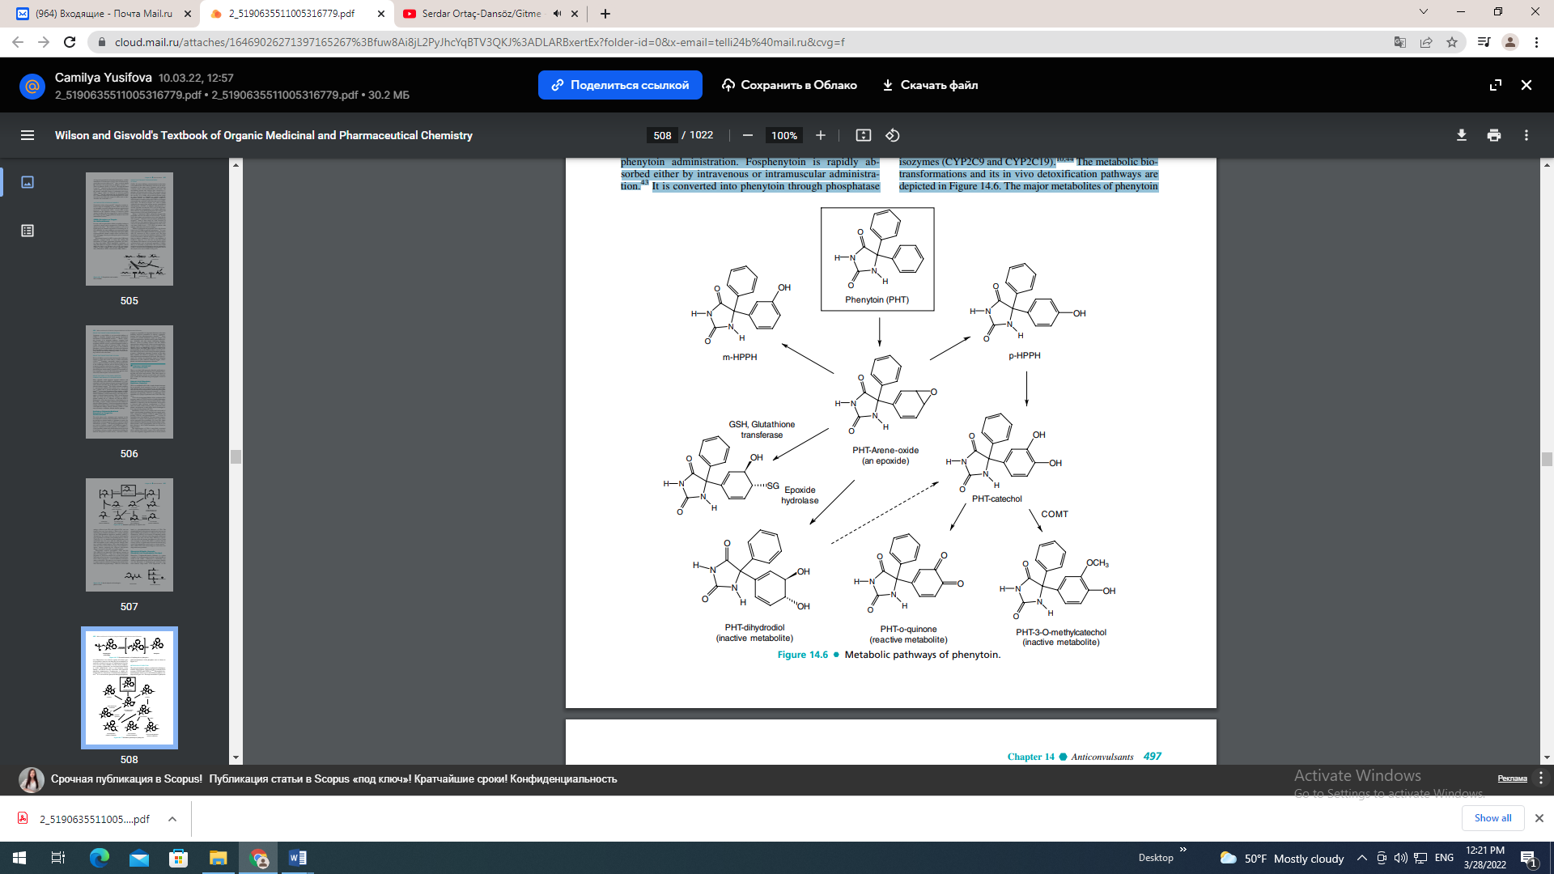
are the 5-(4-hydroxyphenyl)-5-phenyl hydantoins (pHPPH) and dihydrodiol. Both of these inactive metabolites are excreted as the corresponding O-glucuronides. Further oxidation of p-HPPH leads to a catechol metabolite, which appears in the urine as a methyl conjugate by the action of catechol-O-methyltransferase (COMT). HYPERSENSITIVITY REACTION OF PHENYTOIN Hypersensitivity reactions (idiosyncratic toxicity) to phenytoin and other aromatic AEDs in susceptible individuals are believed to stem from the reactions of these reactive intermediates (i.e., arene oxide, catechol, or o-quinone) with hepatic enzymes or other cellular proteins forming covalently bonded haptens.45 The reactive intermediate, arene oxide, is deactivated by either epoxide hydrolase to dihydrodiol (a major urinary metabolite) or by the action of GSH and glutathione transferase. It has also been suspected that these reactive arene oxides or epoxides mediate the teratogenicity of phenytoin and other AEDs. Recent studies indicate that epoxide hydrolase might be useful as a biomarker for prenatal determination of risk of fetal hydantoin syndrome.46,47 Again, glutathione and epoxide hydrolase are important for detoxification of these reactive metabolites. Furthermore, a normal level of COMT in the liver or kidneys also greatly reduces the amount of catechol, which can be easily oxidized to the reactive o-quinone. Thus, COMT and the NADPH-dependent quinine oxidoreductase may play a protective role in phenytoin-induced toxicities.48 Both phenytoin and phenobarbital are potent liver enzyme inducers. Both of these drugs induce cytochrome P450 isozymes CYP1A2, CYP2C9/19, and CYP3A4, as well as epoxide hydrolase and UDP-glucuronyl transferase (phase II enzyme responsible for glucuronide formation).10 Thus, for patients who are using multiple drugs, their plasma concentrations for drugs metabolized by these enzymes will be greatly affected. Phenobarbital and Primidone (Mysoline) Although sedative–hypnotic barbiturates commonly display anticonvulsant properties, only phenobarbital display enough anticonvulsant selectivity for use as antiepileptics. Primidone (Mysoline) is metabolized by CPY2C9/19 to phenobarbital and phenylethylmalonamide (PEMA) as shown in Figure 14.7. Both of these metabolites have anticonvulsant activities. However, it is generally believed that the pharmacological action of primidone is mainly a result of the minor metabolite, phenobarbital. Thus, primidone is much less potent/toxic than phenobarbital, because most of the drug is rapidly degraded to the less potent metabolite, PEMA.49 Carbamazepine (Tegretol) and Oxcarbazepine (Trileptal) CBZ, 5H dibenz[b,f]lazepine 5 carboxamide is an iminostilbene derivative of tricyclic antidepressants.50 The two phenyls substituted on the urea nitrogen fit the pharmacophore pattern suggested for binding to the VGSC21 (Fig. 14.1). Like phenytoin, CBZ is useful in generalized tonic–clonic and partial seizures. The major metabolic pathway of CBZ is the formation of a stable metabolite, 10,11-CBZ epoxide by cytochrome P450 isozyme CYP3A4. This reactive metabolite is further deactivated by the action of epoxide hydrolase to give inactive 10,11-CBZ-diol that is excreted as the corresponding glucuronides50 (Fig. 14.8). The epoxide is a suspect in the idiosyncratic reactions CBZ may produce (e.g., aplastic anemia).48 OXC is a newer AED with a similar mechanism of action to CBZ except for its metabolic inactivation pathway. It is also not a liver enzyme inducer like CBZ and phenytoin.43,50 With the presence of a carbonyl function at the C10 carbon, OXC is reduced to the corresponding CBZ-10-ol by the action of alcohol dehydrogenase that is excreted as its
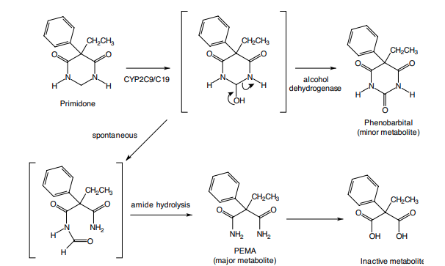

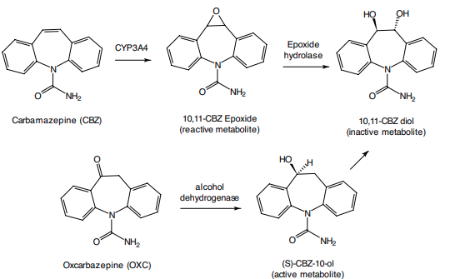
O-glucuronide or can be further oxidized to the 10,11-CBZdiol as an inactive metabolite (Fig. 14.8). Thus, OXC is said to have much fewer hepatic and idiosyncratic side effects associated with CBZ.23 Although OXC does not induce its own metabolism, it is a weak inducer of CYP3A4 and UDPglucuronyl transferase and also inhibits CYP2C19. Thus, severe drug–drug interactions with medications metabolized by these enzymes are to be expected.43 Gabapentin (Neurontin) and Pregabalin (Lyrica) Gabapentin and its closely related analog pregabalin, (S)-3-isobutyl-GABA (Fig. 14.9), are broad-spectrum anticonvulsants with multiple mechanisms of action.24,51 In addition to modulating calcium influx and stimulate GABA biosynthesis as discussed earlier, they also compete for the biosynthesis of L-glutamic acid because of their structural similarity to L-leucine.51 Gabapentin and pregabalin have very little liability for causing metabolicbased drug–drug interactions, particularly when used in combination with other AEDs because they are not metabolized in humans. More than 95% of the drug is excreted unchanged through the kidneys. However, there are some differences in their bioavailability. Unlike gabapentin, which exhibits 60% bioavailability when given in low doses because of intestinal uptake by a saturable small neutral L-amino acid transporter, the absorption of pregabalin is almost complete (98%) and exhibits an ideal linear pharmacokinetic profile.24 This high bioavailability of pregabalin can be attributed to its closer structure similarity to the essential amino acid, L-leucine. FELBAMATE (FELBATOL) AND FLUROFELBAMATE FBM, another potent and effective AED with a broad spectrum of action, is a carbamate ester of 2-phenyl-1, 3- propanediol, structurally similar to the anxiolytic drug meprobamate.43 The carbamate ester is stable to esterases and therefore provides good oral bioavailability. However, the FBM therapy was found to be associated with rare but severe side effects such as aplastic anemia, idiosyncratic reactions, and hepatic failures within 6 months of its market introduction.52,53 Extensive clinical metabolic studies with FBM have been able to link the formation of reactive metabolite(s) and the clinically observed toxicities.52 FBM undergoes hepatic cytochrome P450-mediated hydroxylations (i.e., catalyzed by hepatic isozymes, CYP3A4, and CYP2E1) to give 2-hydroxyfelbamate (2-OH-FBM) and p-hydroxyfelbamate (pOH-FBM) that are excreted as their corresponding glucuronides (Fig. 14.10). However, FBM also undergoes esterase-catalyzed hydrolysis to give two minor metabolites, 2-phenyl-1, 3- propandiol monocarbamate (MCF) and 3-carbamoyl-2- phenylpropionic acid (CPPA). It has been suggested that during the oxidative degradation of MCF to CPPA, the intermediate, 3-carbamoyl-2-phenylpropionaldehyde could be converted to a potentially toxic reactive metabolite, 2-
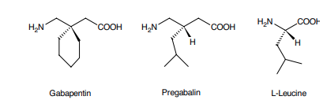
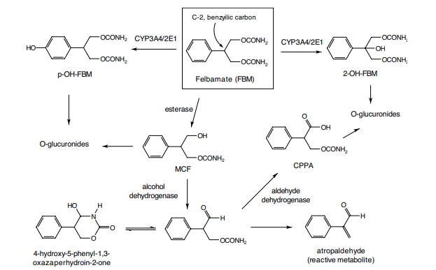
phenylpropanal (atropaldehyde) that is normally deactivated as a cysteine conjugate via the GSH/glutathione transferase pathway discussed earlier under the metabolism of VPA.39 Isolation of 4-hydroxy-5-phenyl-1, 3-oxazaperhydroin-2-one (i.e., a precursor for 2-phenylpropionaldehyde in human urine) provided further evidence linking this toxic metabolite to the observed clinical toxicities.53 Similar to VPA discussed earlier, placement of a fluorine atom at the C-2 position of FBM resulted in a very potent anticonvulsant, 2-fluorofelbamate that lacks the idiosyncratic properties of FBM. Fluorofelbamate is currently under phase II clinical trials.54 It should be pointed out that although FBM has no effect on CYP2C9, it is an inhibitor of CYP2C19 and also inhibits the mitochondrial enzymes responsible for -oxidation. Thus, drug interactions between FBM and VPA are to be expected.55 Novel Broad-Spectrum Anticonvulsants Chemical structures of these newer broad-spectrum anticonvulsants are shown in Figure 14.11. All of these drugs have unique mechanisms of action and will be discussed in individual drug monographs.
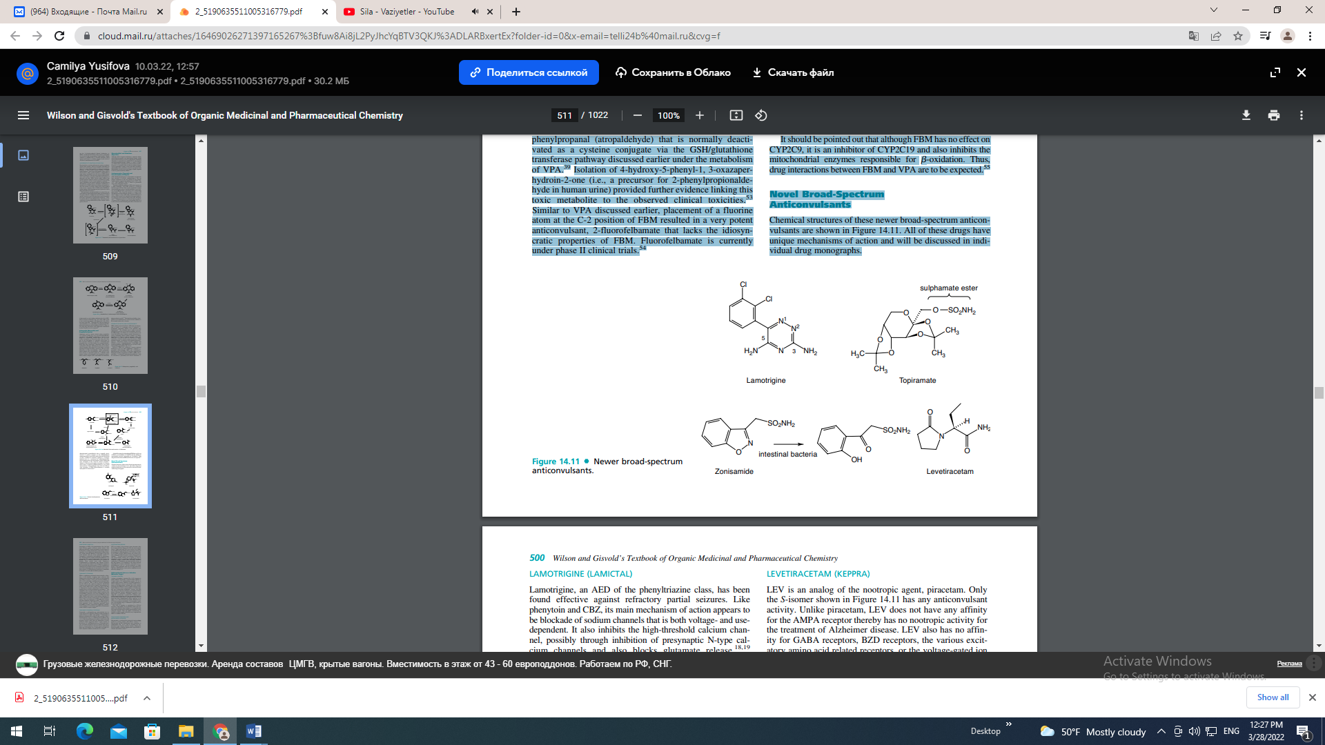
LAMOTRIGINE (LAMICTAL) Lamotrigine, an AED of the phenyltriazine class, has been found effective against refractory partial seizures. Like phenytoin and CBZ, its main mechanism of action appears to be blockade of sodium channels that is both voltage- and usedependent. It also inhibits the high-threshold calcium channel, possibly through inhibition of presynaptic N-type calcium channels and also blocks glutamate release.18,19 Lamotrigine is metabolized predominantly by glucuronidation. The major inactive urinary metabolites isolated are 2-Nglucuronide (76%) and 5-N-glucuronide (10%) because the aromatic ring is somewhat deactivated by the presence of chlorine atoms toward arene oxide formation.56 Coadministration of lamotrigine with valproate, however, greatly increases the incidence of its idiosyncratic reactions.56 It is conceivable that in the presence of VPA, an inhibitor of UDP-glucuronyl transferase, the concentration of the reactive arene oxide intermediate may be increased because of the reduced capacity of UDP-glucuronyl transferase to metabolize lamotrigine via normal glucuronidation pathways. TOPIRAMATE (TOPAMAX) TPM is a sulphamate-substituted monosaccharide, a derivative of the naturally occurring sugar D-fructose that exhibits broad and potent AED actions at both glutamate and GABA receptors.19 It has good oral bioavailability of 85% to 95%, most likely resulting from its structural similarity to D-glucose. Thus, it may be actively transported into the brain by the D-glucose transporter. (Recall that D-fructose and D-glucose have identical stereochemistry at many of their chiral centers.) Only about 20% of the drug is eliminated by hepatic metabolism (CYP2C19), the remaining drug is excreted unchanged by the kidneys.57 The sulphamate ester is hydrolyzed by sulfatases to the corresponding primary alcohol, which is further oxidized to the corresponding carboxylic acid. Even though there are no reports of significant interactions between TPM and other AEDs, TPM is said to have a weak carbonic anhydrase inhibitory activity because of the presence of the sulphamate moiety. Thus, concomitant use of TPM with other carbonic anhydrase inhibitors should be avoided.57 The exact mechanism of actions are still unknown, but TPM appears to block glutamate release, antagonize glutamate kainic acid/AMPA receptors, and increase GABAergic transmission by binding to a site distinct from BZDs or barbiturates on the GABAA receptor complex.19 ZONISAMIDE (ZONEGRAN, EXCEGRAN) Zonisamide, a sulfonamide-type anticonvulsant was recently approved for adjunctive therapy in the treatment of partial seizures in adults with epilepsy.43 Zonisamide is primarily metabolized by reductive ring cleavage of the 1, 2-benzisoxazole ring to 2-sulfamoyl-acetyl-phenol (Fig. 14.11). This biotransformation is mainly carried out by the intestinal bacteria rather than the mammalian cytosolic aldehyde oxidase suggested earlier.58 Again, because of the presence of a sulfonamide moiety in zonisamide molecule, precaution should be given to patients who have a history of hypersensitivity reactions toward sulfonamide drugs and concomitant use of zonisamide with other carbonic anhydrase inhibitors should also be avoided.59 LEVETIRACETAM (KEPPRA) LEV is an analog of the nootropic agent, piracetam. Only the S-isomer shown in Figure 14.11 has any anticonvulsant activity. Unlike piracetam, LEV does not have any affinity for the AMPA receptor thereby has no nootropic activity for the treatment of Alzheimer disease. LEV also has no affinity for GABA receptors, BZD receptors, the various excitatory amino acid related receptors, or the voltage-gated ion channels.43,60 For this reason, its mechanism of anticonvulsant action remains unclear, but it appears to exert its antiepileptic action by modulating kainite/AMPA-induced excitatory synaptic currents, thus decreasing membrane conductance.60 Furthermore, the anticonvulsant activity of this drug appears to be mediated by the parent molecule rather than by its inactive metabolite, (S)--ethyl-2-oxo-1- pyrrolidineacetic acid (i.e., via the hydrolysis of amide group).61 Like gabapentin, LEV has few drug interactions with other AEDs thereby can be used in combination to treat refractory epilepsy.10,56 Anticonvulsants Acts on a Selective Molecular Target TIAGABINE (GABITRIL) A glance at tiagabine’s structure (Fig. 14.12) suggests an uptake inhibitor. Reportedly, it blocks GABA reuptake as a major mode of its anticonvulsant activity. Its use is against partial seizures. Inhibitors of GABA transporter-1 (GAT-1 inhibitors) increase extracellular GABA concentration in the hippocampus, striatum, and cortex, thereby prolonging the inhibitory action of GABA released synaptically. Nipecotic acid is a potent inhibitor of GABA reuptake into synaptosomal membranes, neurons, and glial cells. However, nipecotic acid fails to cross the blood-brain barrier following systemic administration because of its high degree of ionization. Tiagabine, marketed as the single R()-enantiomer, a potent GAT-1 inhibitor structurally related to nipecotic acid, has an improved ability to cross the blood-brain barrier, and it has recently received Food and Drug Administration (FDA) approval as an AED.43 It is well absorbed and readily metabolized by CYP3A4 to an inactive metabolite, 5-oxo-tiagabine (oxidation of the thiophen ring) or eliminated as glucuronide of the parent molecule. Over 90% of tiagabine is metabolized by CYP3A4 isozymes.62 The primary site of metabolic attack is the oxidation of the thiophen rings leading to 5-oxo-tiagabine that lacks anticonvulsant activity and the glucuronidation via the carboxylic function. Thus, the plasma concentrations of tiagabine would be greatly effected by any compound that induces or inhibits CYP3A4. ETHOSUXIMIDE (ZARONTIN) AND METHSUXIMIDE (CELONTIN) Ethosuximide is considered the prototypical anticonvulsant needed for treating patients with absence seizures.6,19,25 Ethosuximide and the N-dealkylated active metabolite of methsuximide (Fig. 14.12) work by blocking the lowthreshold T-type calcium channels, thereby reducing the hyperexcitability of thalamic neurons that is specifically associated with absence seizure.
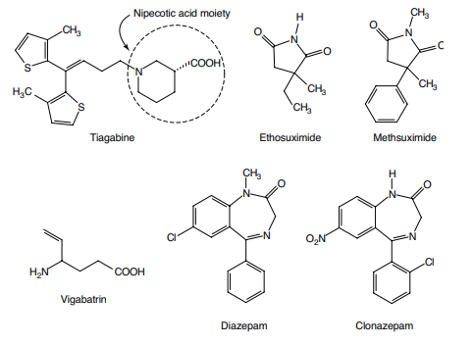
VIGABATRIN (SABRIL)
Vigabatrin, a 4-vinyl analog of GABA, produces its pharmacological action by irreversibly blocking GABA catabolism catalyzed by GABA-T as discussed earlier. It is marketed in Europe and Canada as an adjunctive treatment of patients with partial seizures, but it has yet to gain FDA approval in the United States even after extensive clinical trials.56 The main concern with this drug is its ability to cause a reversible visual field defect associated with retinal function in the eyes.63 BENZODIAZEPINES For details of the chemistry and SARs of the BZDs, see the discussion of anxiolytic sedative–hypnotic drugs. Among the current clinically useful drugs, the structural features associated with anticonvulsant activity are identical with those associated with anxiolytic sedative–hypnotic activity. Clonazepam (Klonopin) Clonazepam is useful in absence seizures and in myoclonic seizures. Tolerance to the anticonvulsant effect of the clonazepam often developed rather quickly, and it is a common problem with the BZDs. Metabolism involves hydroxylation of the C-3 position, followed by glucuronidation and nitro group reduction, followed by acetylation. Diazepam (Valium, Diastat) Diazepam is given orally (Valium) or rectally (Diastat) as an adjunctive treatment in patients with generalized tonic–clonic status epilepticus (i.e., an acute and potentially fatal seizure) or in patients with refractory epilepsy in combination with other AEDs.4 For details on diazepam (Valium), see its discussion under anxiolytics and sedative–hypnotic agents.

